**PowerShell Integrated Scripting Environment**

PowerShell Integrated Scripting Environment (ISE), introduced by Microsoft in PowerShell version 2.0, is a PowerShell host application used to write, test and debug scripts or write commands in a Windows GUI.

PowerShell ISE comes with multiple features, such as syntax coloring, multiline editing, context-sensitive help and tab completion.

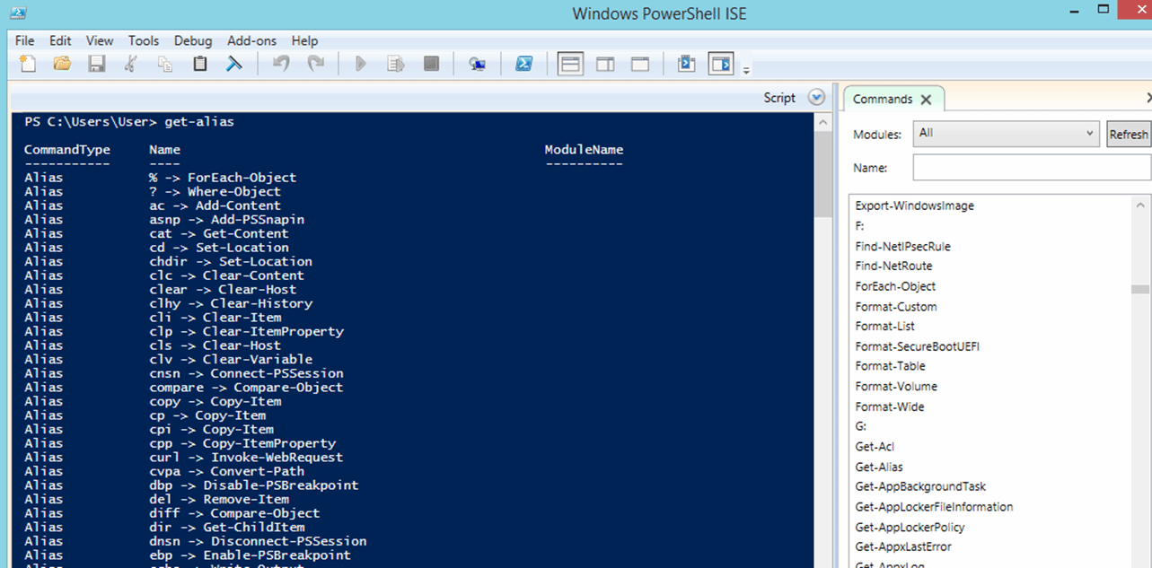

PowerShell ISE has sophisticated features that are familiar to Windows users. For instance, a user can highlight and copy a portion of a PowerShell command with a mouse or with the Shift + Arrow hotkey combination. The user can also paste the content anywhere in the editor window.

Another useful feature is the ability to keep different versions of a command in the editor and run commands that you need in the PowerShell ISE.

The F5 key launches a command directly from the editor. To execute a particular line, select it and press F8. The context-sensitive help displays matching cmdlets when the user starts to enter a command. A command add-on shows a list of cmdlets to select.

PowerShell ISE provides tabs to allow work on multiple administrative tasks. PowerShell ISE enables quick switching from the CLI to scripting mode.

### Language constructs

As a scripting language, PowerShell offers several language constructs that control the flow of scripts, while making decisions as to what should be done. Some of the language constructs include conditionals, switches, loops and variables.

Source : searchwindowsserver.techtarget.com/definition/PowerShell